Mental Fortitude
Original Game & Analysis Project
Milestone 4 – GDD
Game Design II
Brian Rodriguez
0004795418

Table of Contents
Overview 2
Theme 2
Detailed Mechanics 3
Goals 3
Rules 3
Actions 3
Transitions 4
Items 4
Setup 4
Diagrams 5
Milestone 2 Playtest Report 13
Individual Playtests 13
Analysis 16
Action Plan 18
Milestone 3 Playtest Report 20
Individual Playtests 20
Analysis 27
Action Plan 31
Milestone 4 Playtest Report 32
Individual Playtests 32
Analysis 36
Action Plan 43

MENTAL FORTITUDE GAME DESIGN DOCUMENT

Overview
Mental Fortitude is a 2D Side-Scroller where you play as someone with the ability to control the minds of certain creatures around your environment. Using your mind control powers, you’ll need to control enemies to traverse the environment or to attack other enemies on your way to collect the sacred crystal.

Theme
The theme of the game is Mind Control. The way in which the game explores this theme is allowing the players to control the minds of enemies around them as there only form of defense and attack.

Detailed Mechanics
Main Mechanics:
Mind Control – when the player focuses the character becomes unable to move and an icon shows up that allows you to take control of an enemy nearby.

Goals
Players must traverse the area avoiding obstacles that get in their ways and using their Mind Control powers to use enemy abilities to their benefit.

Rules
To win the game, players must make it to the end of the map and collect a crystal.
The player losses a live when there hp reaches 0 or if they fall off the map.
Player only starts of with 3 Lives. After they die with no more lives player losses game.
There are unique enemies that each have a specific movement or ability. There are enemies act as projectiles that the player can control and aim, and others that can block the players path.

Actions
Character Actions:
- Walk – Player can walk on left and right.
- Jump – Players can jump upwards about twice the players height.
- Mind Control – Player can take control of the minds of some enemies. They can do what over the enemy can do.

Mind Controlled Enemies:
Bomber Enemy
- Fly – can fly around in X and Y axis.
- Explode – explodes when It comes in contact with an object.
Blocker Enemy
- Push – they push and damage things that touch their shields.
- Turn – they look at the direction the player is located.
- Jump – Can jump to reach higher places.

Transitions
Level:
There’s one level broken up into 4 sections.
- Section 1 – Teaches players to avoid spikes by jumping over them.
- Section 2 – Teaches the player about checkpoints and moving platforms.
- Section 3 – Teaches players about buttons on the floor that need to be stepped on to move the walls with the same color as the button.
- Section 4 – Teaches the player that they can Mind Control enemies and use them to press buttons that the player can’t reach.
- Section 5 – Mix of Section 1 and 4.
- Section 6 – Introduces Health Potions and Bomber Enemies.
- Section 7 – Teaches That Bomber enemies can be used to destroy Spikes Walls.
- Section 8 - Mixes Section 4 and Section 7.
Menus:
Start menu – from her players can start the game or quit the game. Clicking start load the Game scene and Clicking Quit Closes the game. Can also click on Credits to see where the assets are from.
Pause Menu – when the player is in game, they can press esc key to go into the pause menu. In the pause menu they can press “Continue” to un-pause the game, “Quit” to close the game or “Back to Start” to go to the Start Scene.
Death:
When player dies, the Loss Scene is loaded. From here players can Start, Quit the game or see Credits.
Win:
When player wins, the Win Scene is loaded. From here players can Start or Quit the game. They can also see the Credits.

Items
Everything the player can interact with
- Checkpoints – respawns player at the last checkpoint they touched
- Coin – can be collected. Once a certain amount of coins are collected, player get an extra life.
- Boomer enemies – can be controlled by the player and use to destroy spiked walls.
- Blocker enemies – can be controlled by the player and use to push buttons they cant reach.

Setup
Scene Order:
- Start
- Game
- Loss
- Win

Diagrams
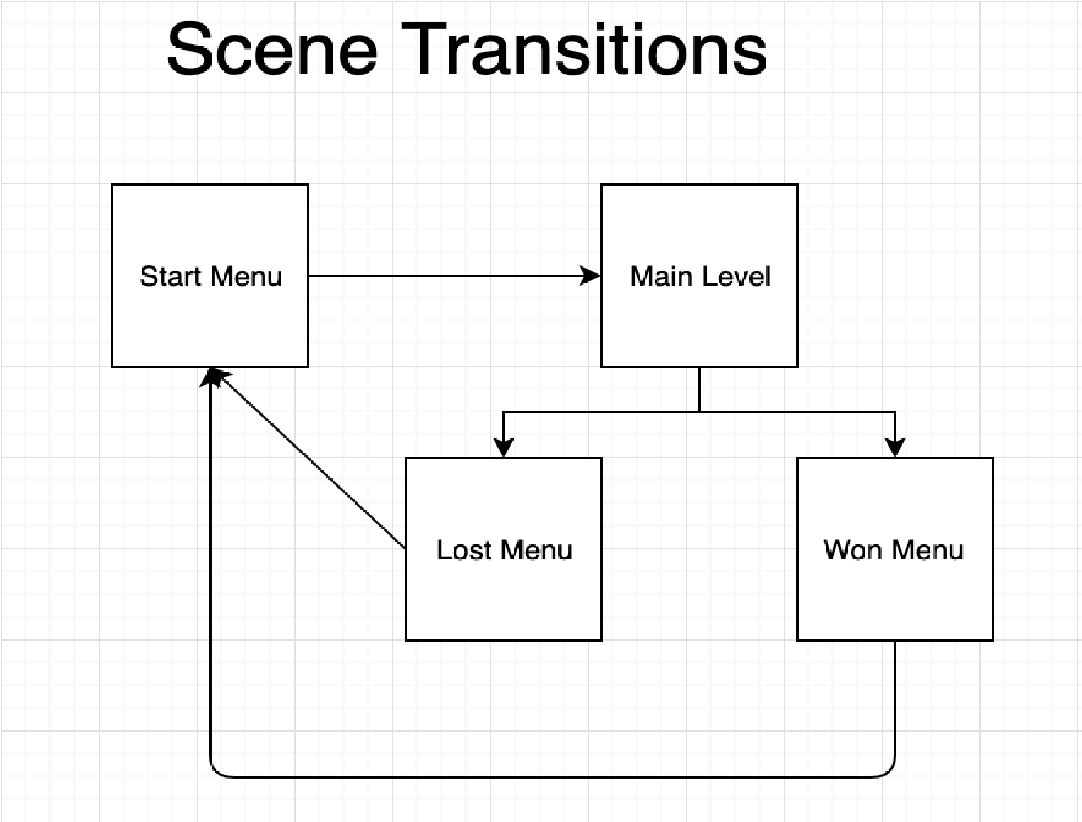

Read Post Boards Storyboard:
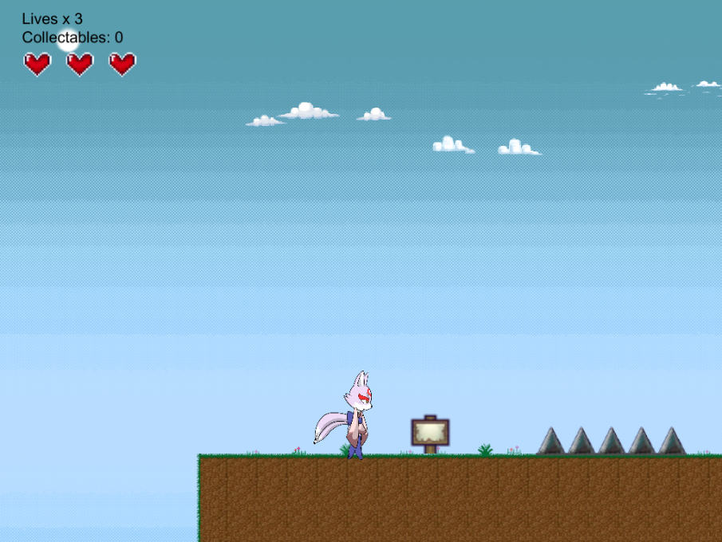
Post boards are scattered throughout the level with useful information on how to play the game.
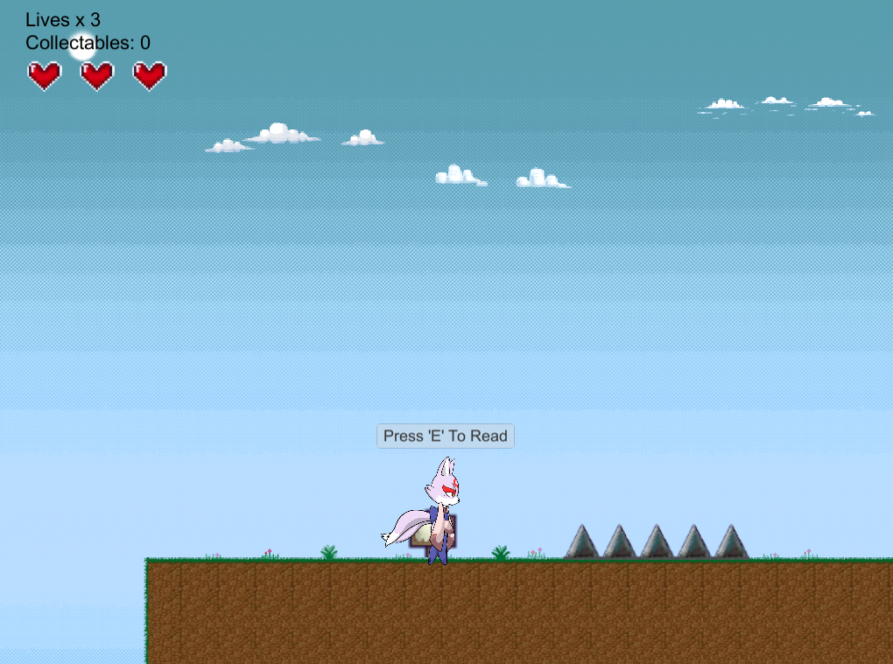
“Press E To Read” pops up above the players head when he is close enough to read the board.
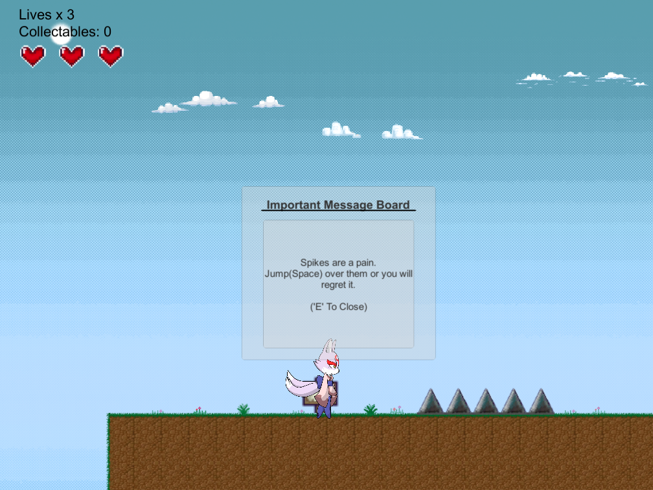
After pressing E, a window pops up showing you want on the board. If you press E of move out of range the window closes again.

Jump Storyboard:
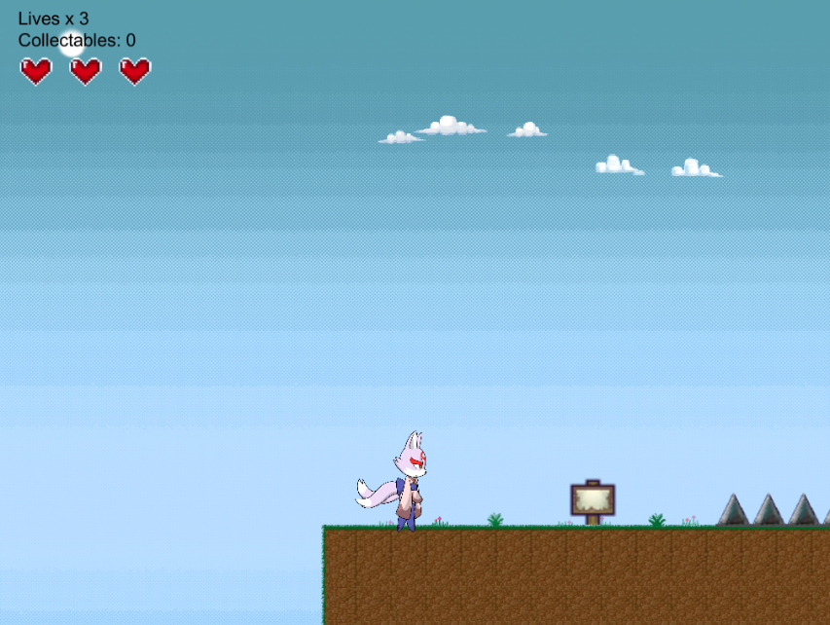
If the player is touching the floor, they can press Spacebar to jump.
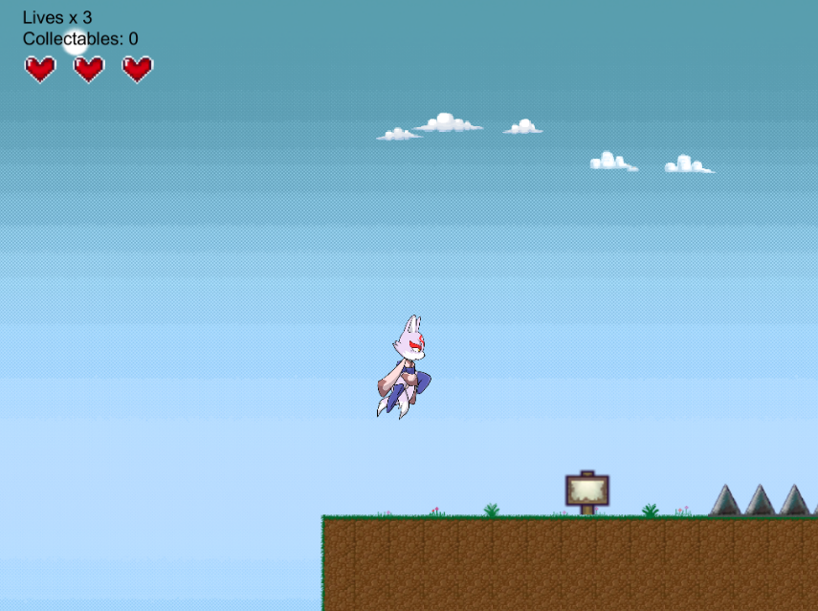
Jumping pushes the player up for a short distance.
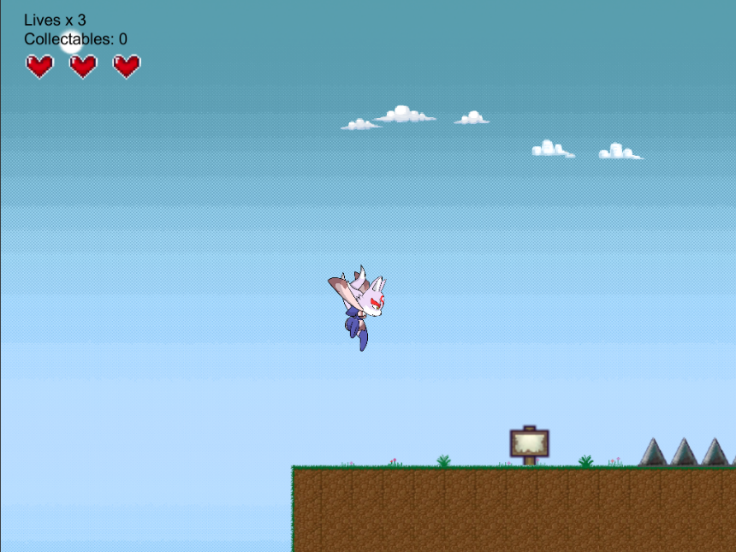
Then goes back down. Player is able to jump again once their feet touches the ground.

Jump Storyboard:
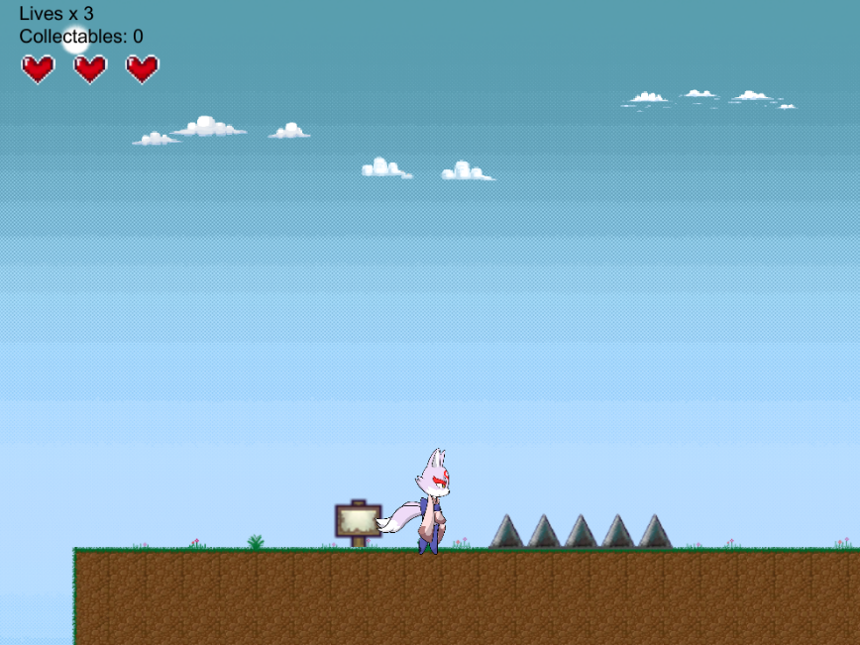
If player touches spikes or enemies, they get hurt and loss a heart.
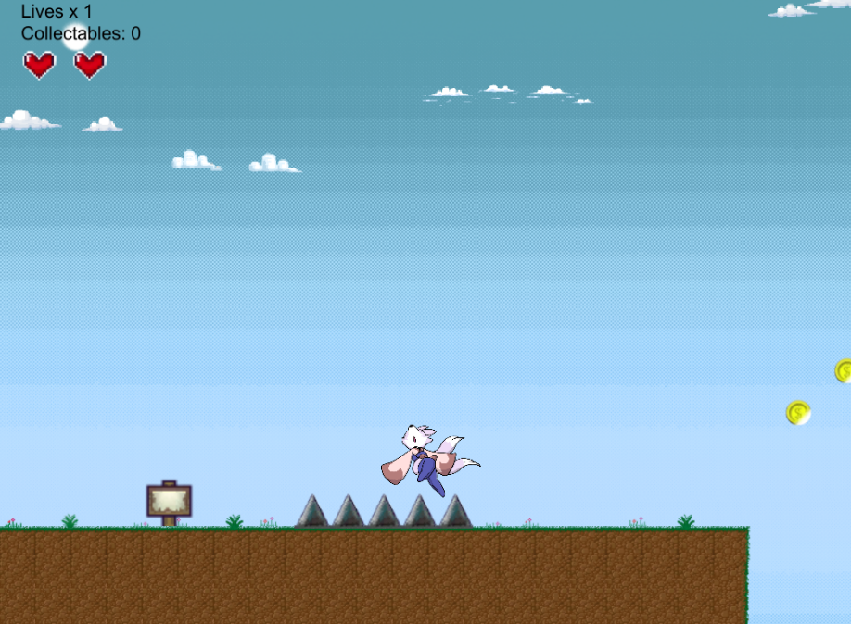
When players get hurt their bodies flinch and are invulnerable to damage for a short period of time.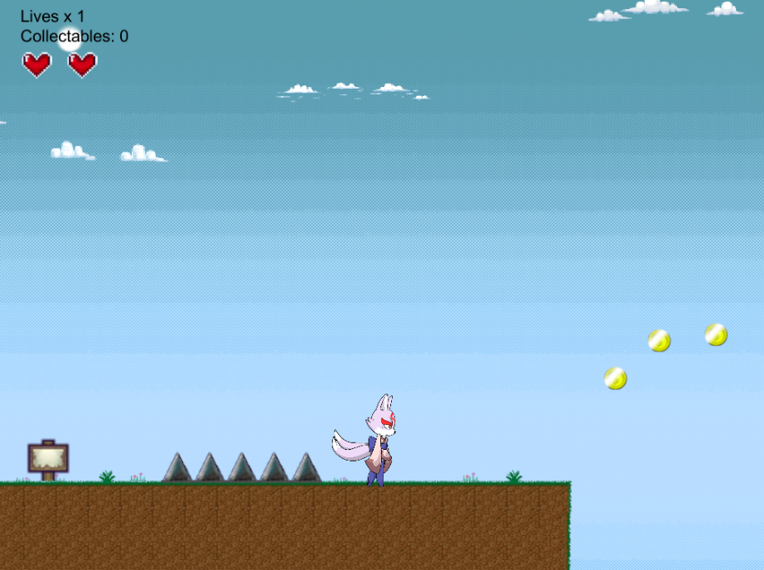

Pressure Plate Storyboard:
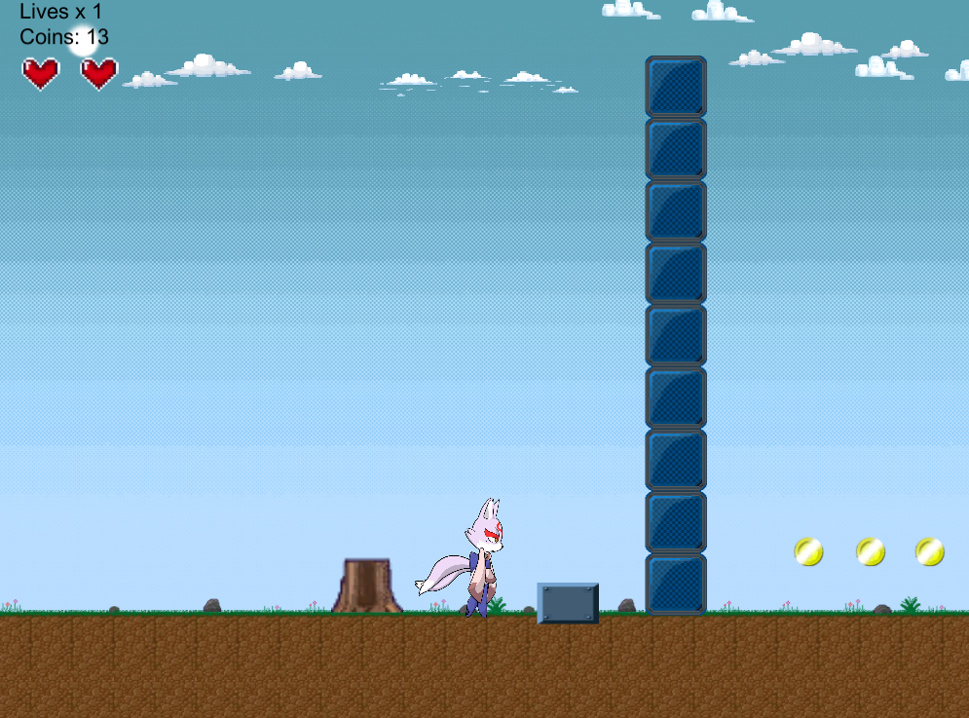
Pressure plates are connected to a wall of the same color.
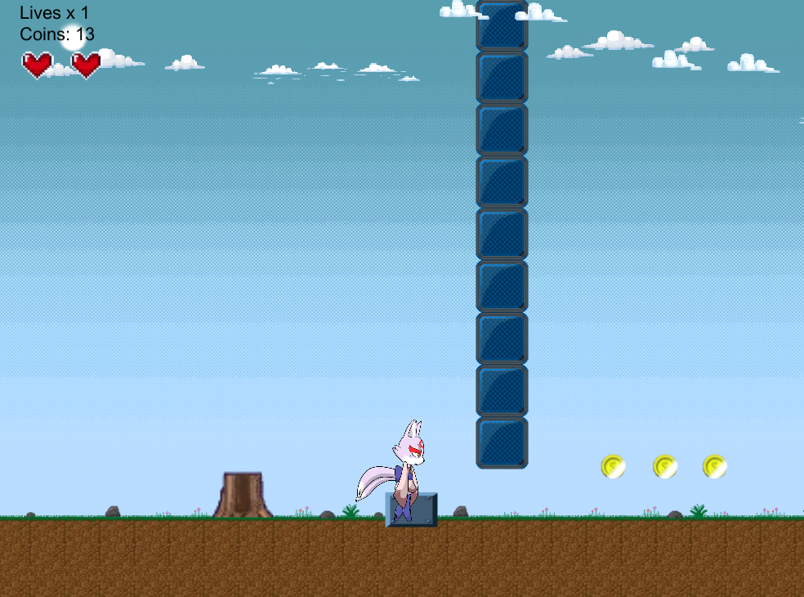
When a player or an enemy controlled by a player steps on the pressure plate, the wall connected to it will rise.
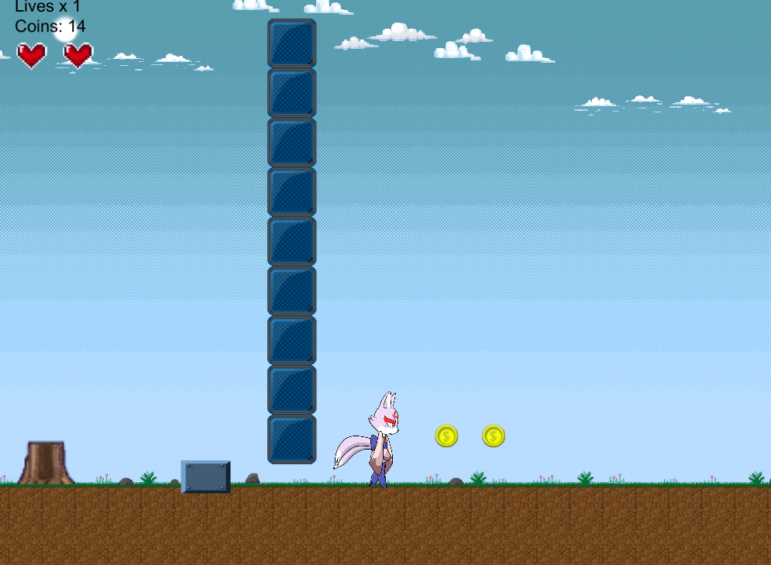
When the player steps of the pressure plate it lowers the wall again.

Mind Control Ability Storyboard:
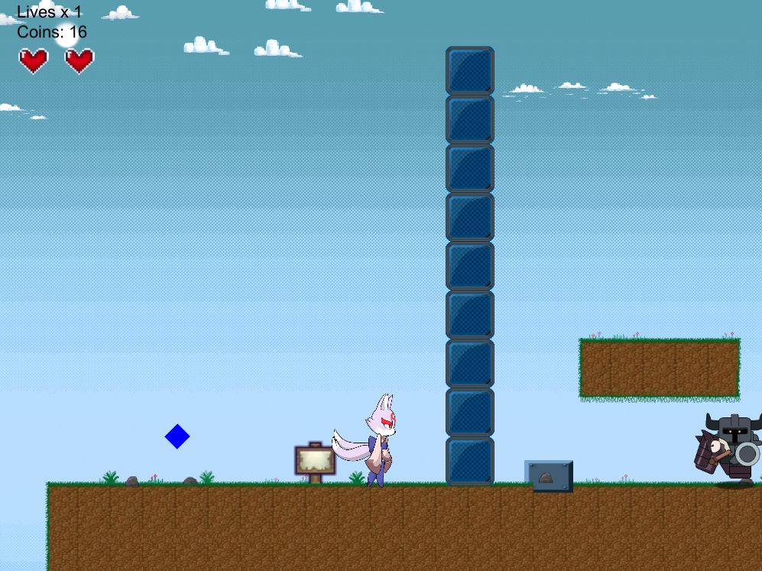
Player can press Q to activate Mind Control.
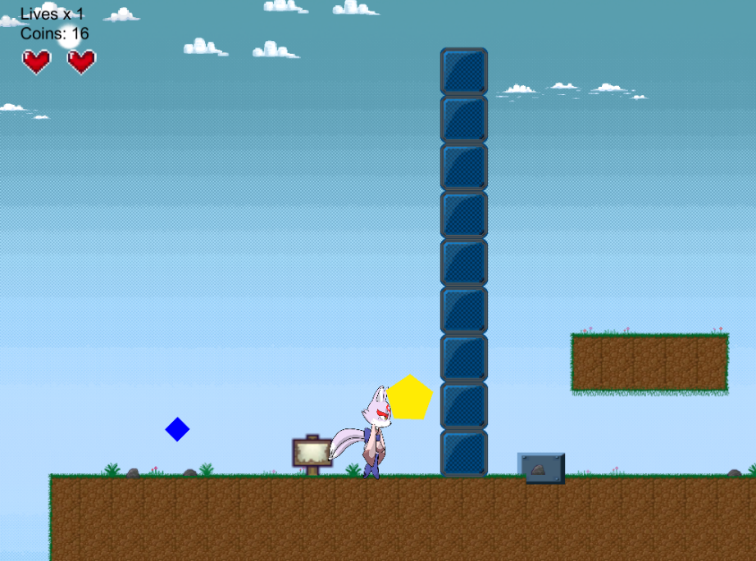
When Mind Control is active, you can control the icon with the same player controls.
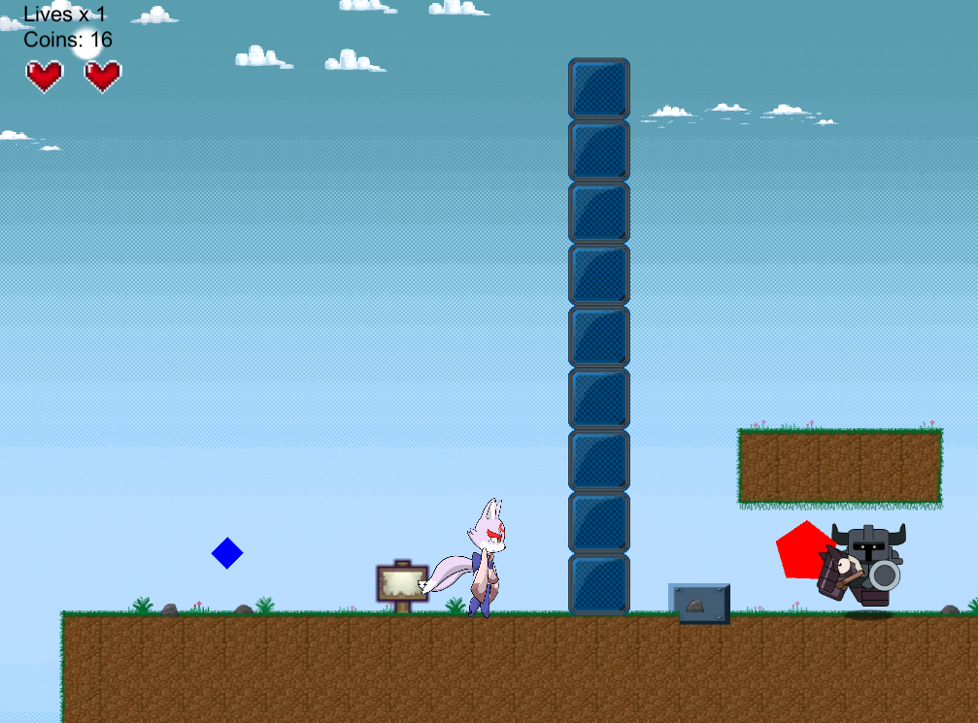
When the icon touches an enemy that can be mind control, it turns red to signal to the player that it’s a valid target.
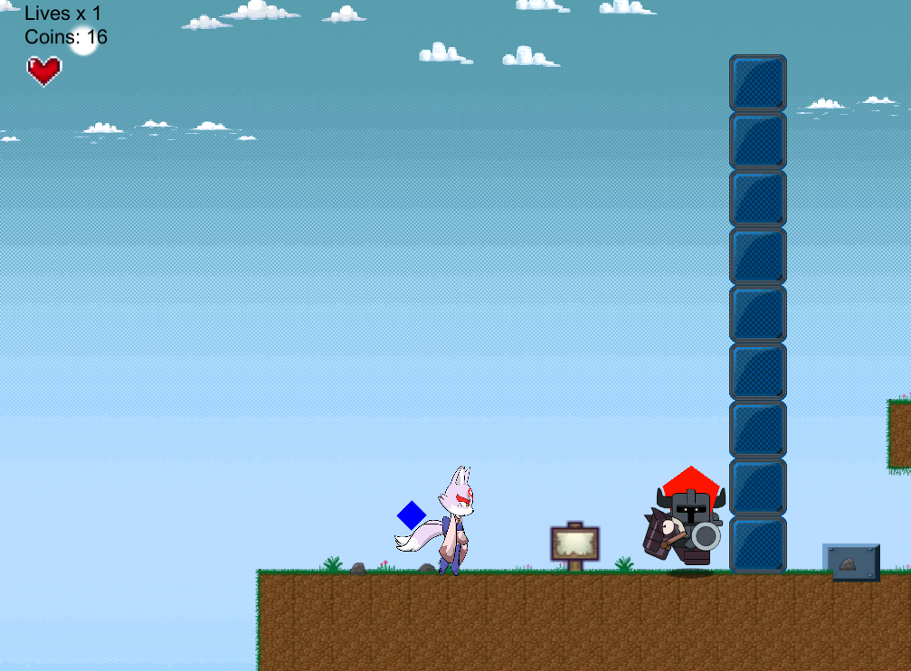
If the target is valid and the player presses E, they can know control the enemy and use their movements. Mind Controlled Enemies had a red Mind Control icon around there head so player know that they are controlling the enemy.

Milestone 2 Playtest Report

Individual Playtests

Playtest # 1
Name: Alicia
Age: 27
Gender: Female
Gaming Experience: RPG
Play Time : 2 mins.
Stuck: Had Trouble maneuvering the character.
Observations:
- The player is difficult to maneuver when on moving platforms.
- Had difficulty passing Blocker enemies that blocked the path.
- Wanted more checkpoint throughout the level

Name: Daniel Inoa
Age: 12
Gender: Male
Gaming Experience: Action, Racing, RPG, Platformer, Shooter, Fighting, Survival, Strategy, MMO, Sports.
Play Time: 5 mins
Observations:
- Kept sliding off Platforms
- If enemy dies while being mind control, then the ability can’t be used anymore.
- Want more collectibles.

Name: Josh
Age: 24
Gender: Male
Gaming Experience: Action, RPG, Shooter, Fighting.
Play Time: 3min
Stuck: taking damage wasn’t obvious so player died multiple times.
Observations:
- Characters slides when enemies hit him.
- Character slide when your moving and activate mind control ability.
- Wants more collectibles on the level.

Analysis
- All play testers seem to have difficulty with the movement of the player since he tended to slide a bit when activating the mind control ability or when standing on moving platforms.
- Players had an easy time understanding how to use the Mind Control ability. A few bugs where found doe. When the player killed an enemy while controlling them, they loss the ability. Also when the player is controling an enemy and something touches them they slide on the platform.
- The Majority of the playTester wanted more Collectibles in the level.
- The majoraty of play testers like the amount of Checkpoints in the level.
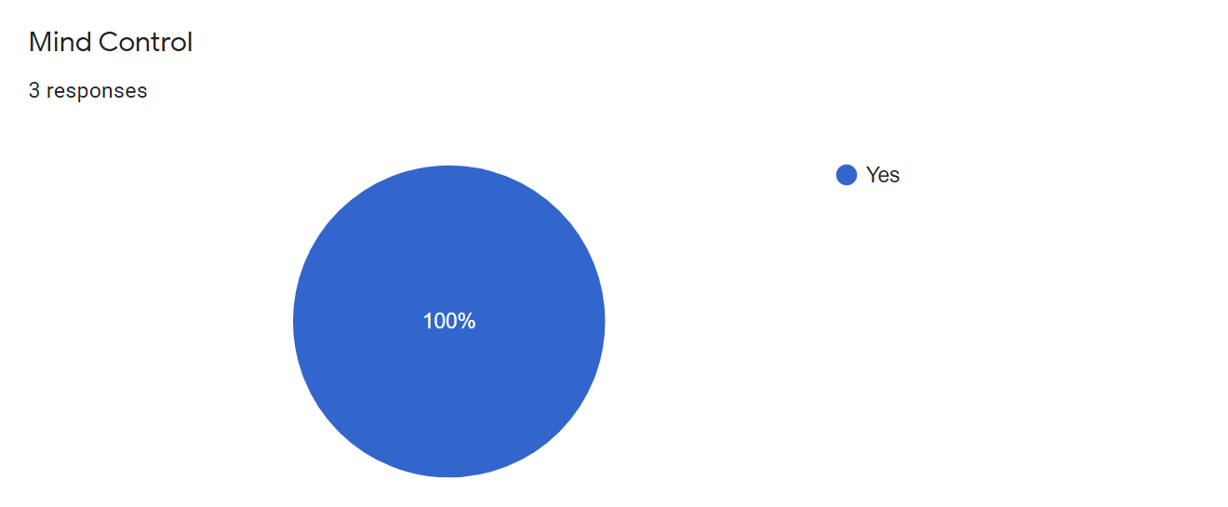
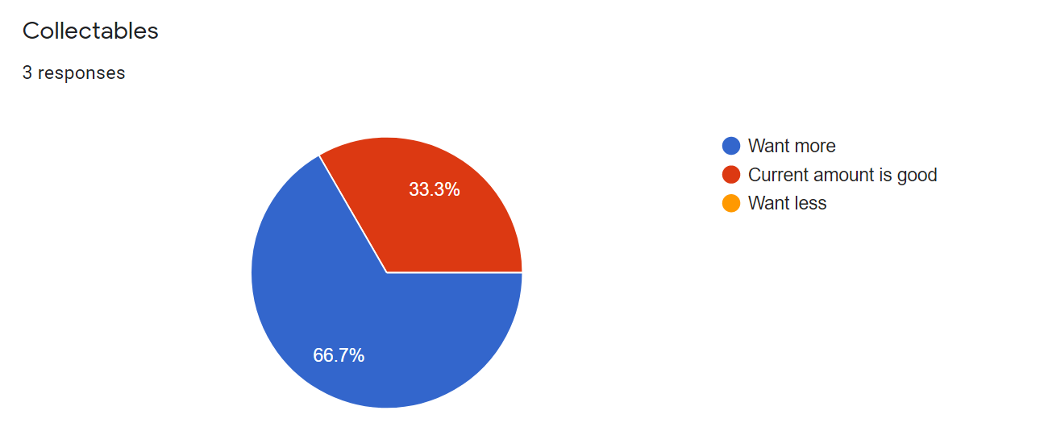
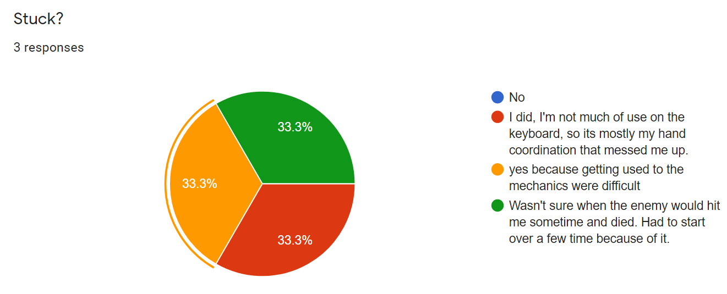
- All players enjoyed the game.

Action Plan
- I’ll work on fixing the characters movement since it seemed to be the biggest issue with all play testers. The major issue was that the player was sliding when they weren’t suppose to.
- I need to make sure that the player can get the Mind control ability back after enemies has died while under mind control.
- I need to add more collectibles around the level to reward the player more.
What will you add to/change in the playtest process (form) to make sure? I will add questions specifically about player movement to make sure I fix the issue for next play test.

Milestone 3 Playtest Report

Individual Playtests

Playtest # 1
Name: Kristopher Legar
Age: 22
Gender: Male
Gaming Experience: Action, Racing, RPG, Platformer, Shooter, Fighting, Survival, Strategy, MMO, Sports.
Playtime: 2min
Stuck: On the second flying enemy.
Observations:
- Loved the Art.
- The movement seemed a bit off.
- When holding Left(A) or Right(D) and then let go, it would run for another second or two.

Name: Ashley K.
Age: 38
Gender: Male
Gaming Experience: Action, RPG, Shooter, Survival, Strategy, MMO, Sports.
Playtime: 2
Stuck: No
Observations:
- Dying is extremely frustrating, you die to a spike or an enemy one time and you start all the way back at the beginning, not good.
- The mind Control is brilliant but difficult to get used to with the controls.
- The Jump function cannot be more perfect.
- The Movement is slightly off.
- As you move the player forward and release the button on the keyboard, the player will move ever so slightly forward still as if there is a 1 second delay from the time you release the button to the time the player stops moving.
- I never made it to the end because of how frustrating the death is.
- Oh, last thing...the hearts don't disappear when you fall. I fell like 10 times in a row but still had 2 hearts on my screen.
Name: Daniel Inoa
Age: 12
Gender: Male
Gaming Experience: Action, Racing, RPG, Platformer, Shooter, Fighting, Survival, Strategy, MMO, Sports.
Play Time: 2 mins
Stuck: No
Observations:
- Needs more enemies
- The movement on moving platforms feel off

Name: Alicia
Age: 27
Gender: Female
Gaming Experience: RPG, Platform, Strategy
Playtime: 6
Stuck: Only at the part when I had to channel the character into the enemy.
Observations:
- The art style.
- The mind channel ability.
- The save points.

Analysis
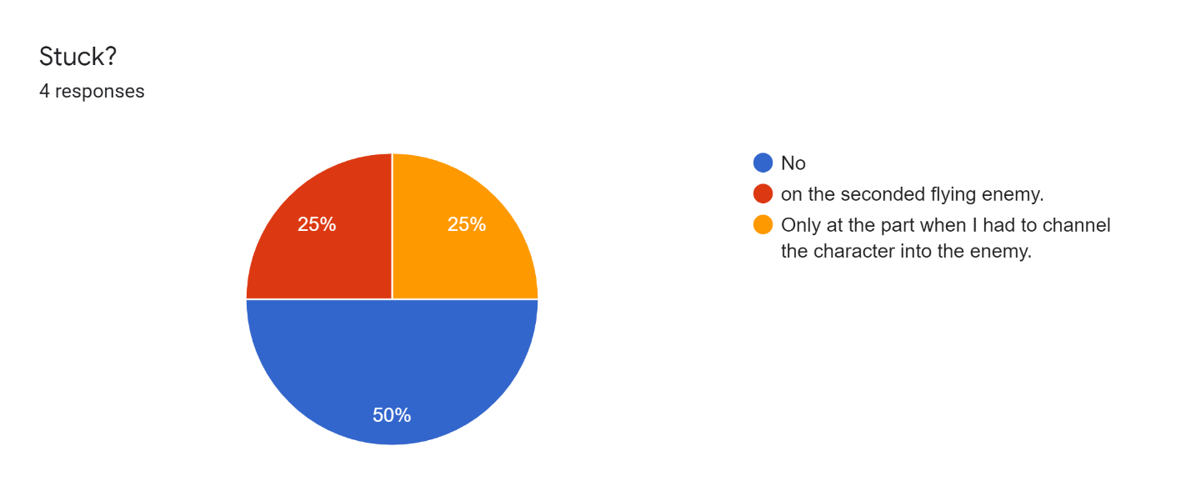
Two out of four players got stuck in similar positions where they came across the BomberEnemy.
1 of them lost control of the Mind Control Ability when they use it on the enemy. This was due to a bad script. I fixed it before others play tested it. The second player that got stuck tried to use a BomberEnemy to kill another enemy which got them stuck since they need it to destroy a spiked wall. I need to make enemies respawn or create more than one way to solve puzzles and obstacles.
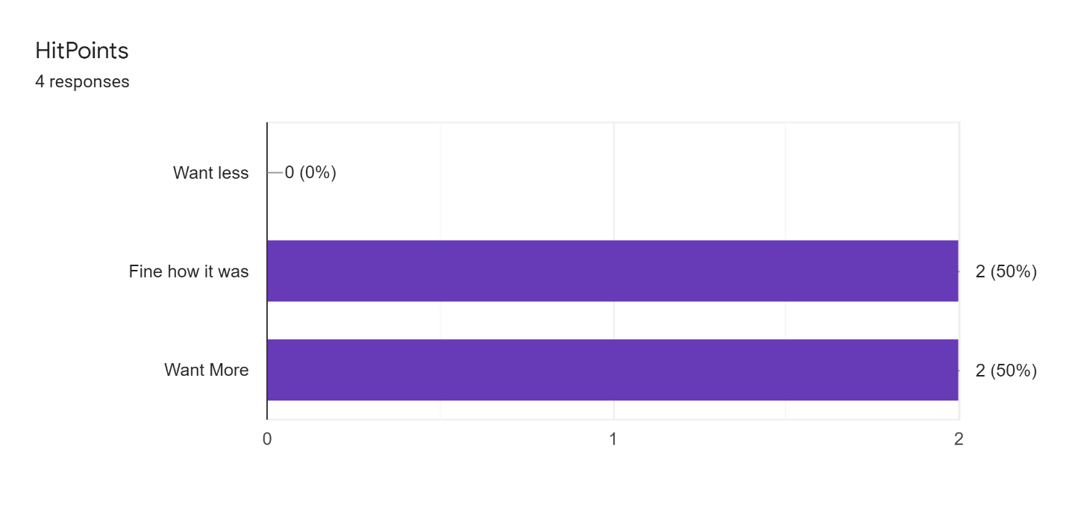
Half the players want more hit points and the other half were fine with the amount they already have. I think ill add more health pickups in areas that have more dangerous obstacles to give the player who need it some help while keeping the same amount of hit points. Increasing hit points too much will make the enemies less of a danger.
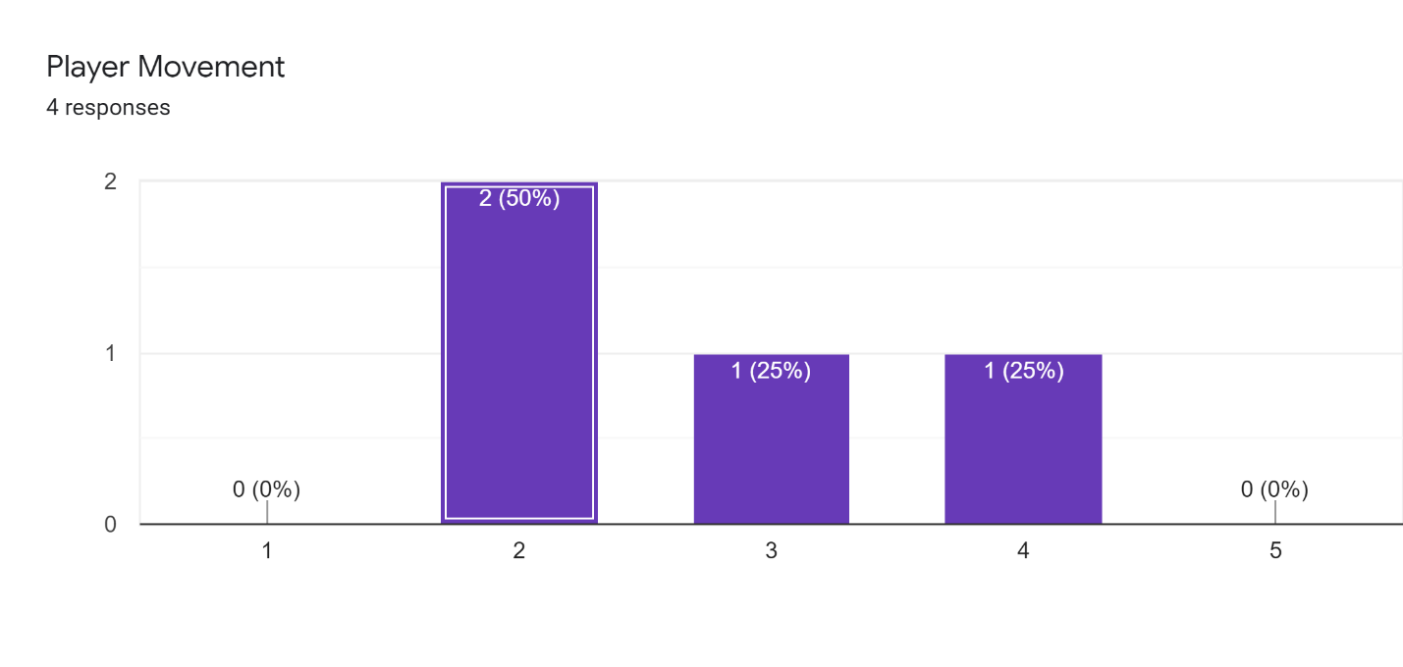
Player movement has improved from last time. Half the player found it a bit difficult to maneuver. One comment was that the movement felt a bit sluggish. I might want to increase the speed of the player slightly and speed up the animation to better match the speed. I think the problem is the animation looks like its running faster than the character is moving making feel a bit weird.
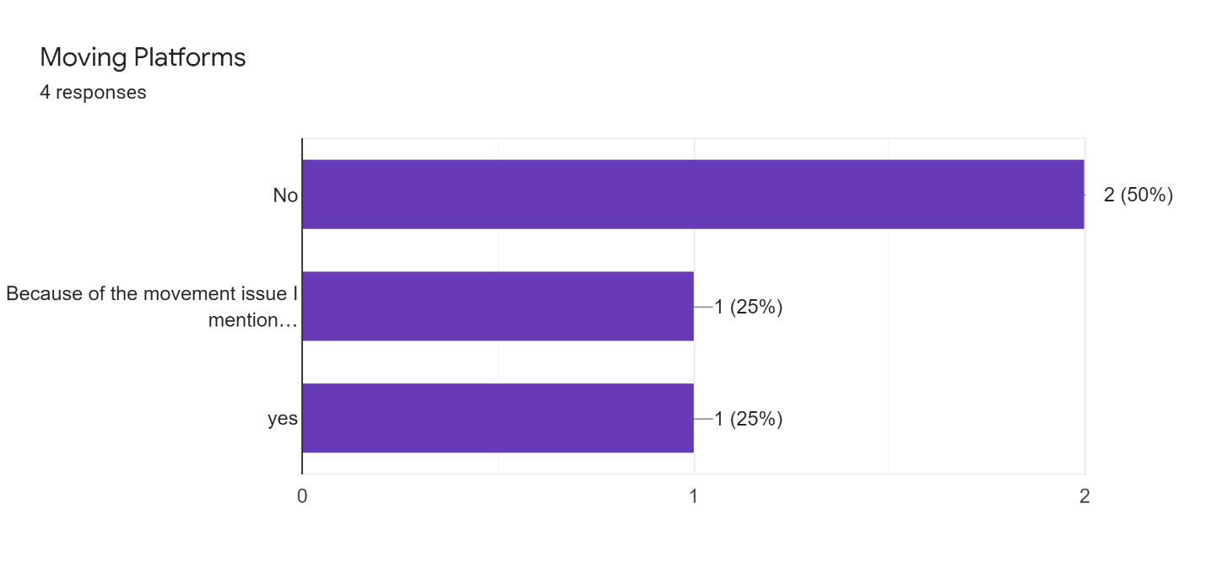
Half the players had a difficult time with the moving platform. They found it difficult to stay on them. This could be because of the problem where the character moves slightly even after you left go of the key. I can make the platform slightly larger to give more room for mistakes and I need to try to fix the moving issue.

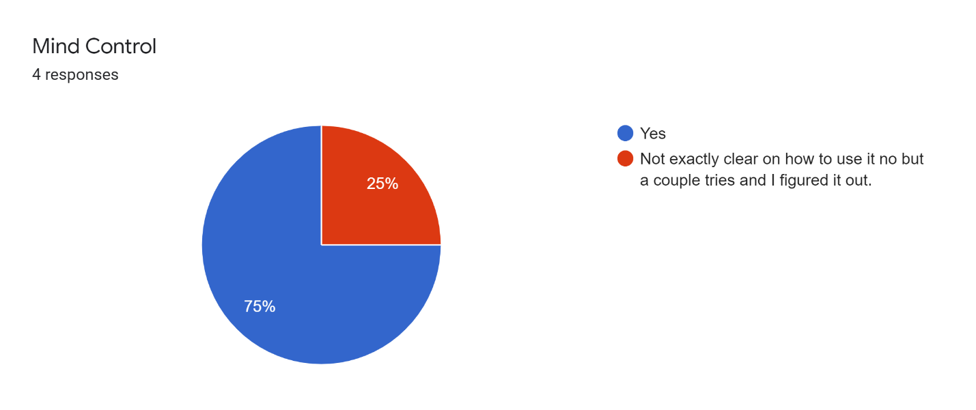
Only one playtester had issue with the mind control ability. Ill try to add more clear instructions on the Billboards in the game.
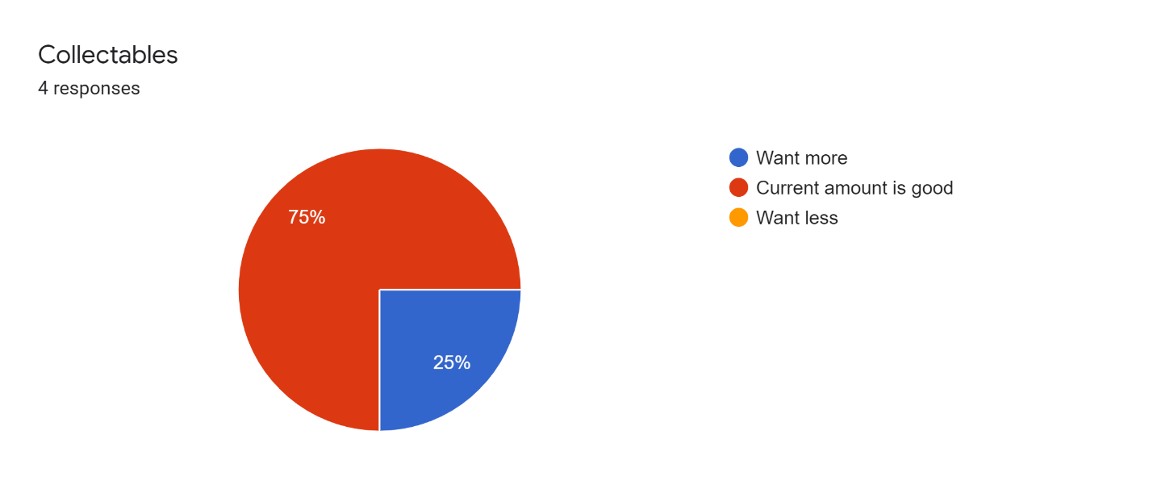
One player wanted more Collectable and the other play testers where fine with the current amount. Ill try to include different types of collectibles that have different values without increasing the amount on the Level.
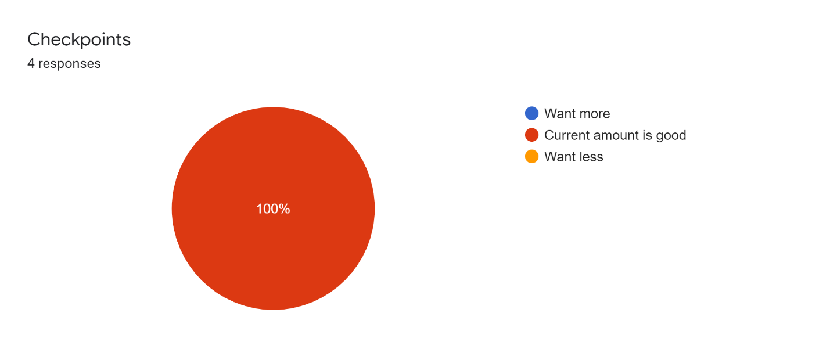
Checkpoints seem to be fine this version of the game.
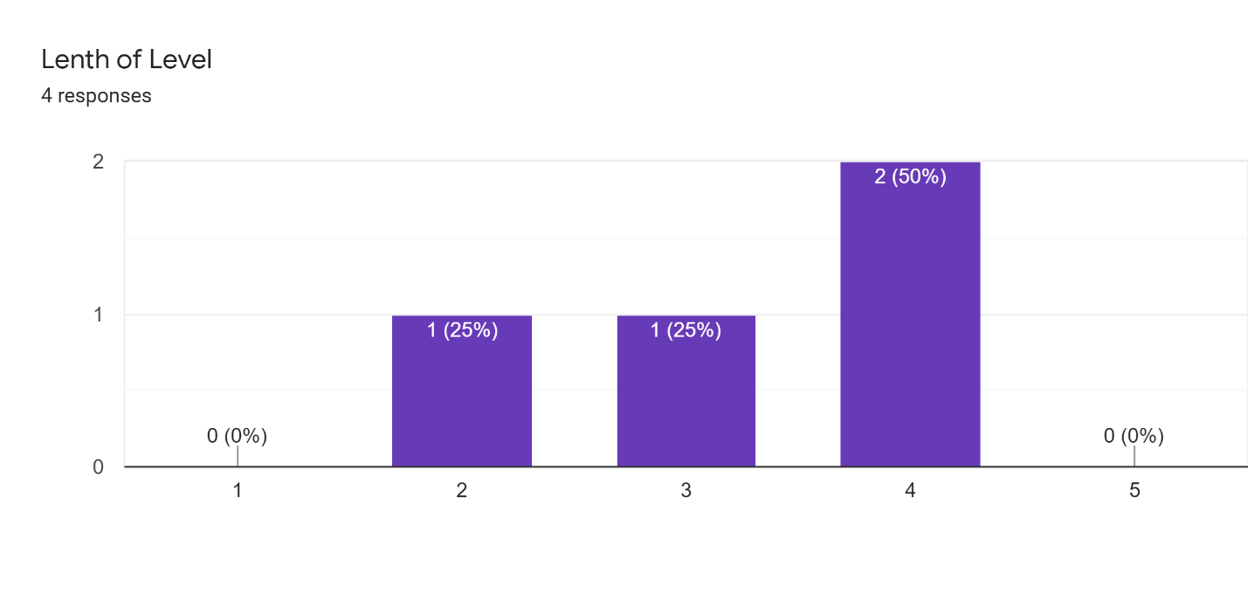
One player thought the level was to short and two thought the level was to long. I might want to break the level into multiple levels to make them feel shorter but increasing the length of the game a bit.

Likes:
The gameplay.
The jump was superb.
The mind control mechanic and the new health potions.
I like the save points, they remind me of the 1st Tomb raider.

Change:
the movement was sticky
When player dies to an enemy or a spike, let them respawn at a checkpoint rather than the very beginning.
The moving platforms
I would change the how to take over the enemy. It was a bit confusing how to take over them, but at the end I understood.

Action Plan
Based on conclusions, what are you going to do about it?
- Try to Make the animation match the characters speed better so it doesn’t seem too sluggish.
- Will increase player movement slightly.
- Will increase size if platforms to give players more of a safety net when platforming.
- Add more types of collectibles.
- Break the level into multiple levels.
- Maybe add mouse control for the Mind Control Icon if time allows.
- Make death less punishable by making them spawn at a checkpoint when they run out of lives instead of starting from the beginning.

What will you add to/change in the playtest process (form) to make sure?
- Questions about the size of the platforms.
- Is the number of levels to much or too little?
- Is the number of potions enough in the levels.

Milestone 4 Playtest Report

Individual Playtests

Playtest # 1
Name: Kimberly Bradley
Age: 19
Gender: Female
Gaming Experience: Action, RPG, Platformer, Shooter, Survival, Strategy, MMO
Playtime: 9 min
Stuck? No

Name: Eric Miller
Age: 30
Gender: Male
Gaming Experience: Action, Racing, RPG, Platformer, Shooter, Fighting, Strategy, MMO, Sports, Puzzle
Playtime: 7 min
Stuck: No
Observations:
- It took a few tries to get used to the movement of the character (speed, jump height, etc.), but the controls were very intuitive.
- I found the mind control ability easy to understand and use on the enemies.
- I noticed my remaining lives appeared to drop to negative values upon restarting from a checkpoint.

Name: Daniel Inoa
Age: 12
Gender: Male
Gaming Experience: Action, Racing, RPG, Platformer, Shooter, Fighting, Survival, Strategy, MMO, Sports.
Playtime: 2mins
Stuck: no
Observations:
- Sound is to loud.
- Platforms are easy to move on.
- Enemies are easier

Name: Christopher North
Age: 19
Gender: Male
Gaming Experience: RPG, Fighting, Strategy, MMO
Playtime: 9min 30sec
Stuck: Yes, I was a bit confused on where to go. I clicked on one thing, but nothing happened
Observations:
- I did like the game. I am sure it is extremely fun. I'm just confused on how it works. Then again, I should have just asked you.

Analysis
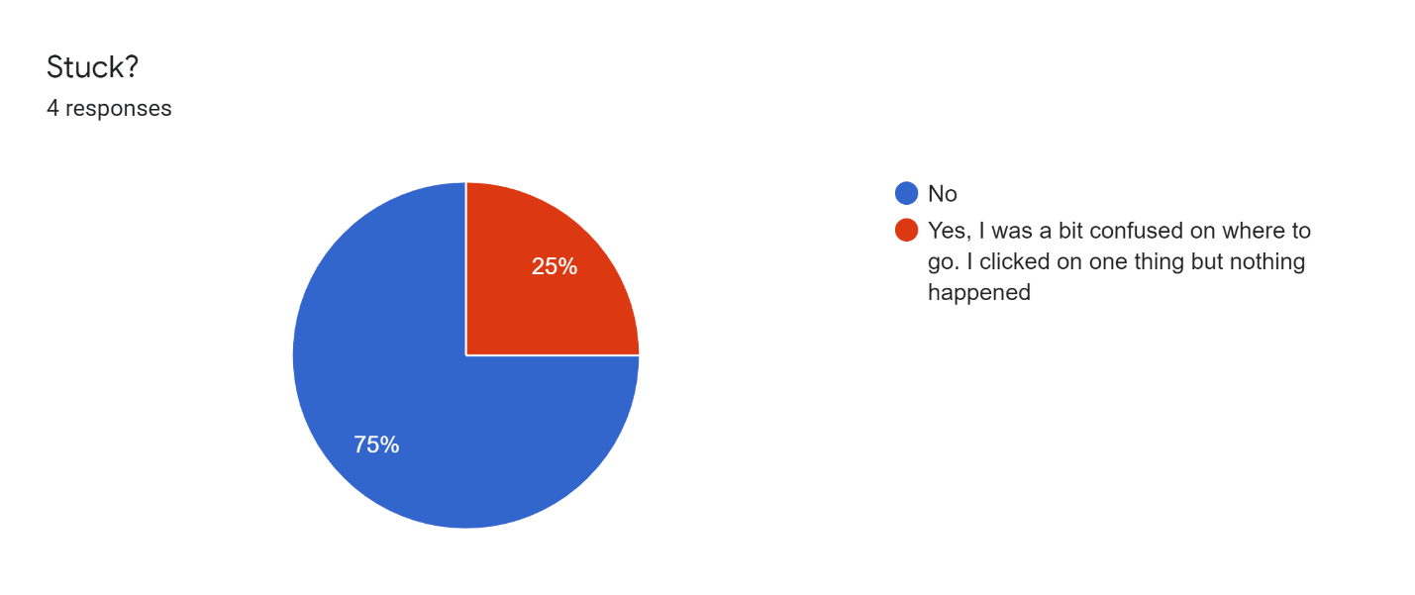
Out of all the players only one player got stuck. It isn’t clear where exactly they got stuck.
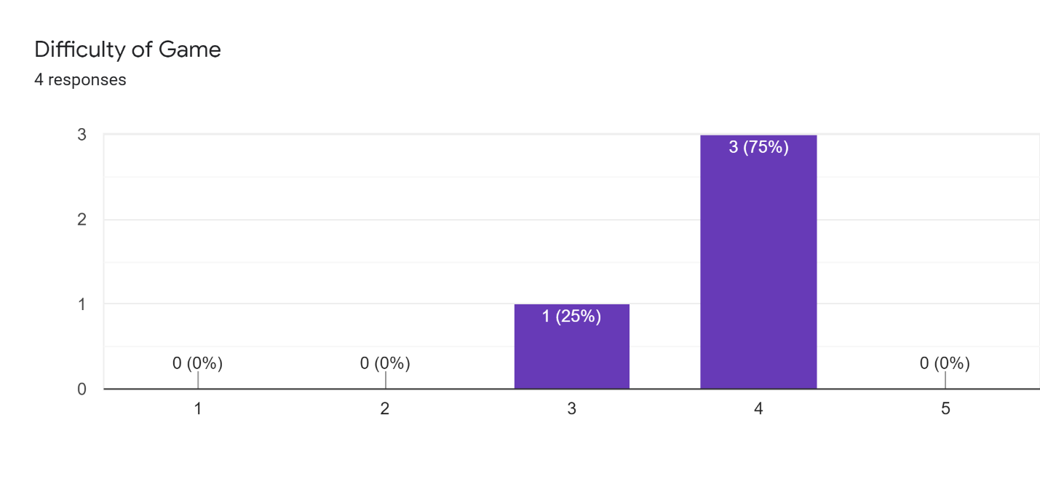
Most play tester thought the game was a bit difficult but not to hard which is what I was going for so I don’t think I need to change much in that area.
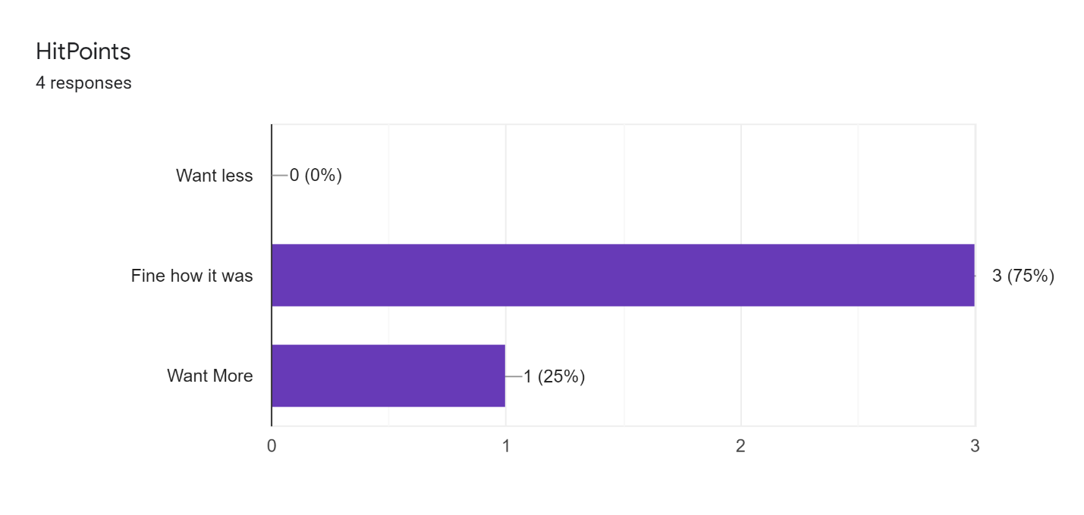
Most players are fine with the amount of health point the player has.
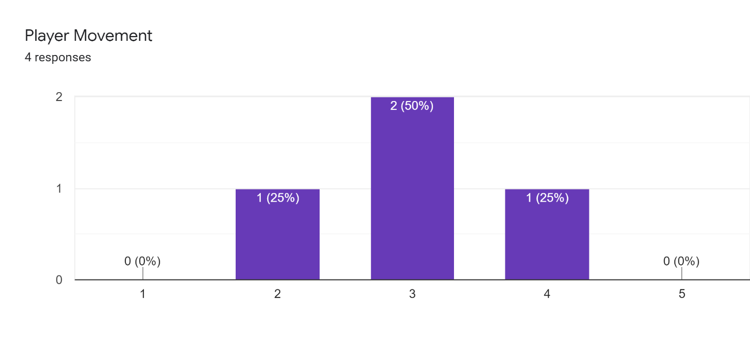
The player movement has improved from last time. I fix the sliding issue from before and that seemed to improve the characters movement feel. Also I think the increase in movement speed helped make the player feel smother then previous build.

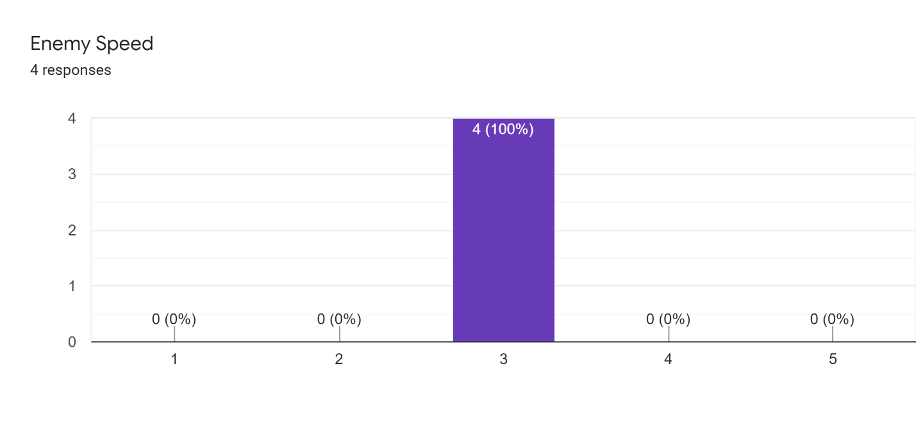
All players seem to find the enemy movement to be the right speed compared to the player.
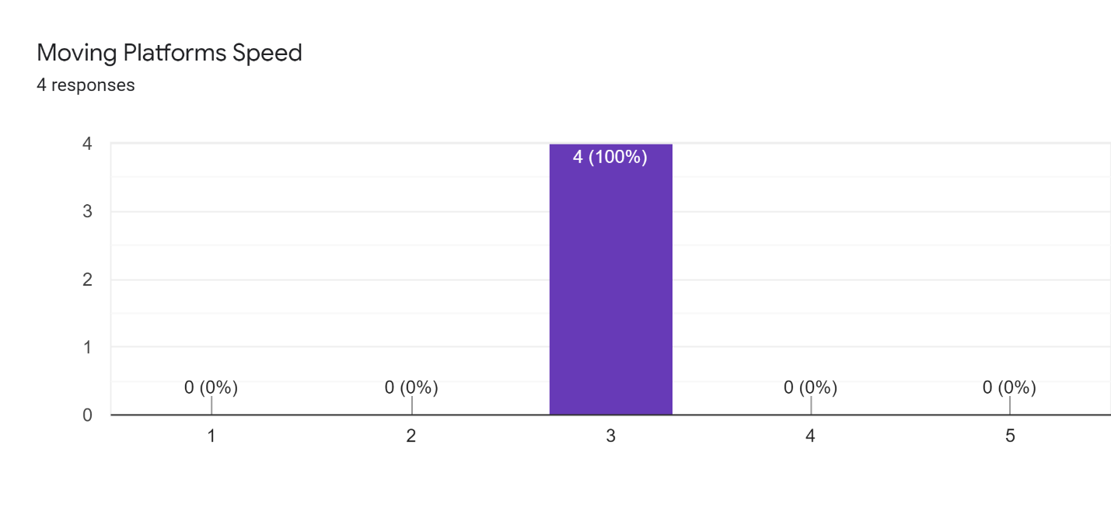
After increasing the movement of the player, the platform speed seemed to feel much better without having to increase their speed.
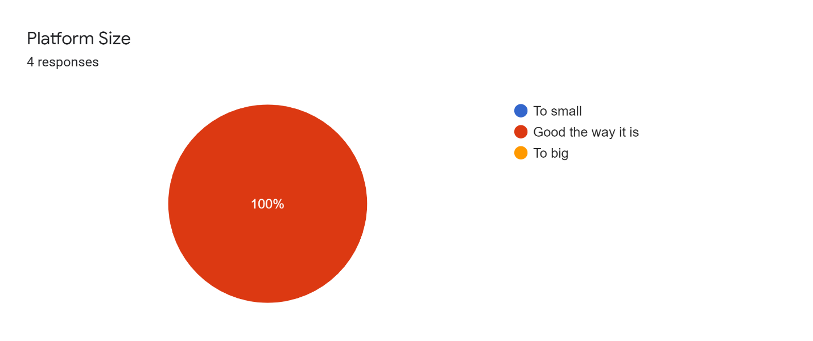
Platforms also felt small before bit fixing the movement of the player made them feel bigger than last build. Fixing the sliding issue with the player I think was the issue making the platform feel smaller than they were.
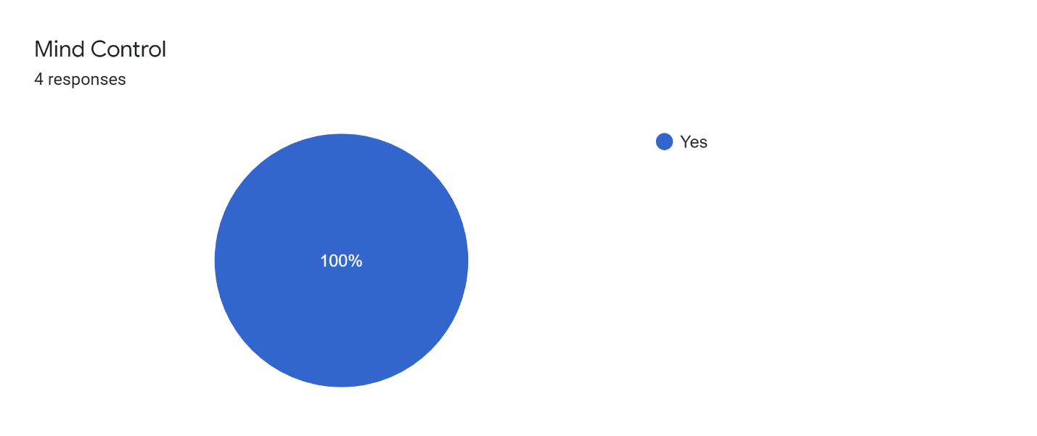
Everyone seem to be satisfied with he way the mind control works on this build. Speeding it up slightly seem to fix the feeling of the controls from the last build.
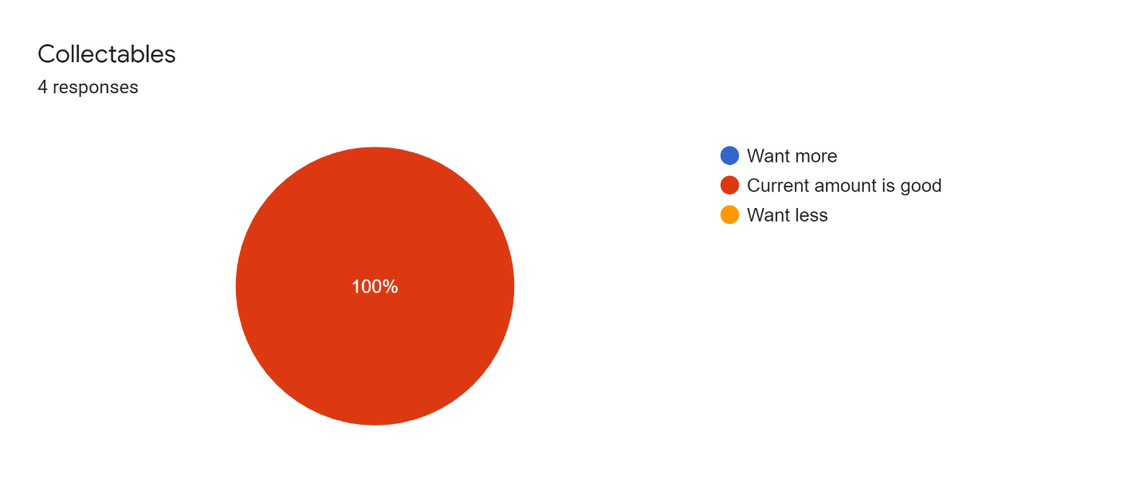
Spreading the collectable further from each other made the collectable amount feel much better. I did not need to add more collectables just separate them slightly through the level.

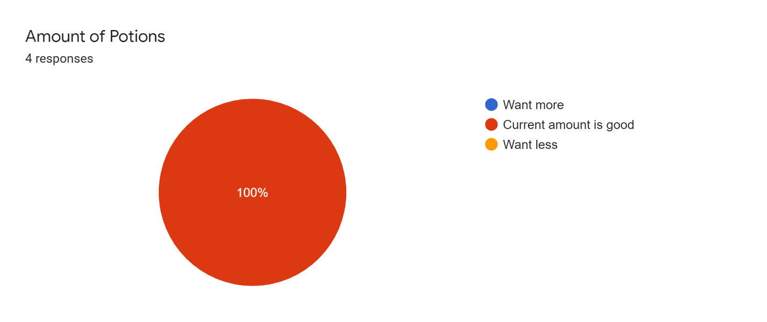
Everyone thought the number of potions in the level was good. One criticism was that the potions should be introduce earlier in the game, so the player knows that there is healing in the game. That makes a lot of sense and will add it next build.

The amount of more Checkpoint I added seem to be fine.
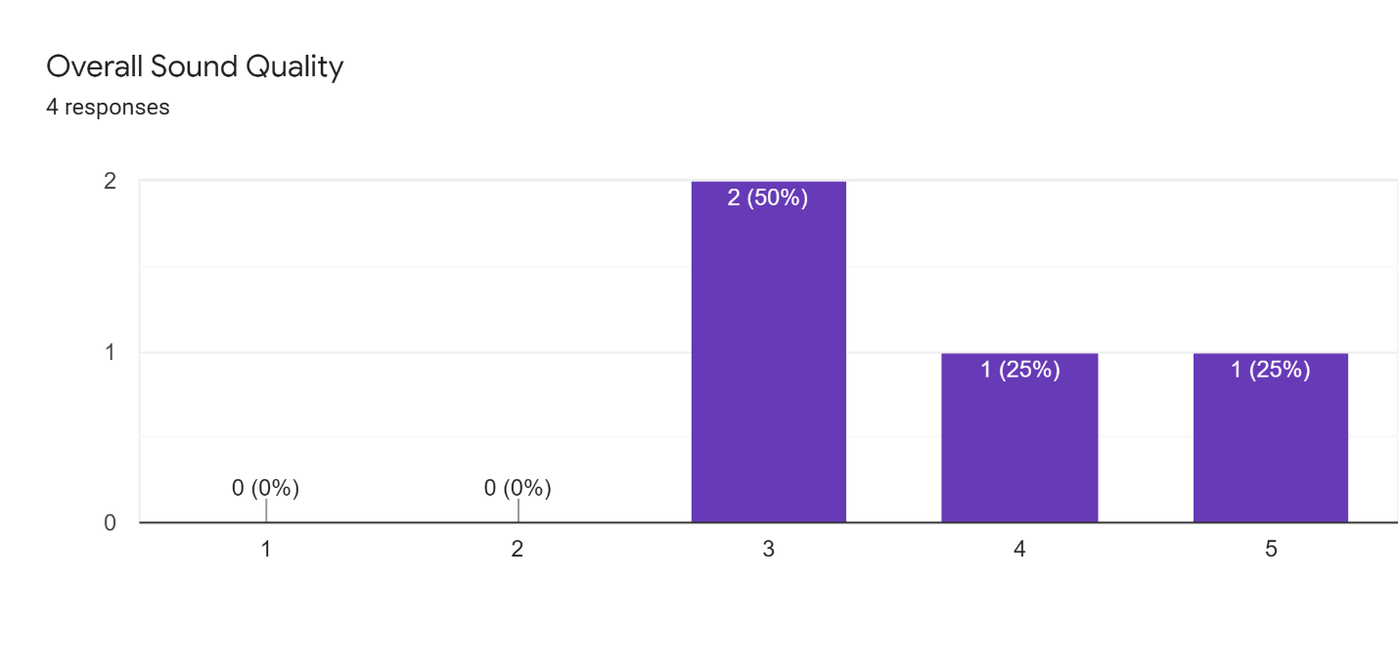
The sound quality was positive. Some of the issues was that the music was to load. I should try to figure out how to add a way to control volume and add it to the pause menu. This would allow each individual player to adjust the sound to what they personally want.
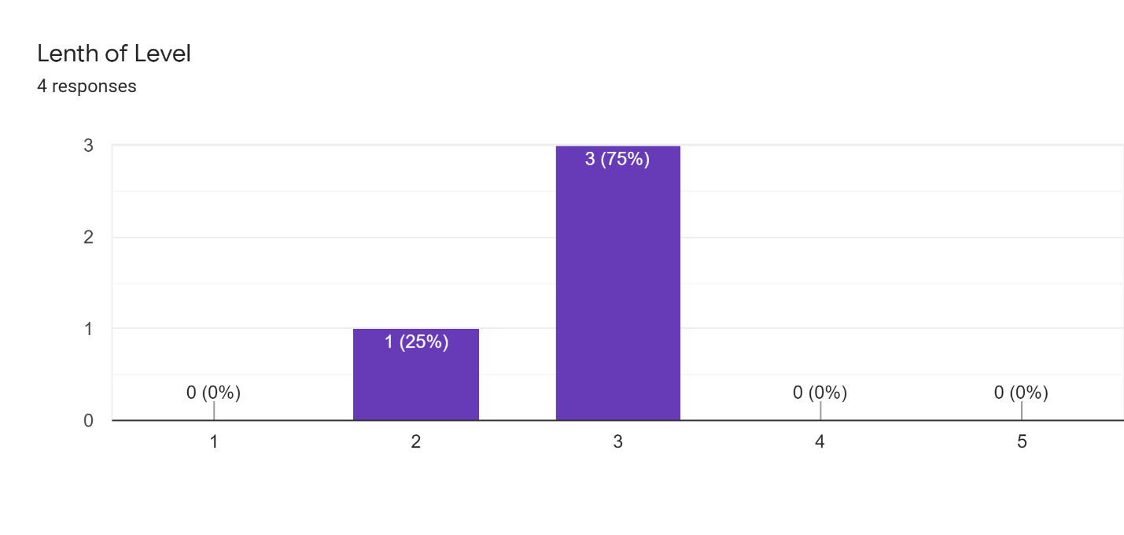
Most player thought that the length of the game was good except one player. The player who finished quickly also had the most game experience out of all the play testers so that’s probably why their time finishing was much faster than the others. If I had more time I would just add harder bonus levels for people who find the main level to easy.

Likes
I really enjoyed the variety of mechanics involved such as the spikes, platforms, different enemies, and the brick walls that the player needs to get past.
The animations and presentation were great.
The character models.

Change
I feel the health potions should be introduced sooner so that the player can use them in the beginning after the spikes so that the player knows there is something to help even if they mess up.
The first enemy needs to be placed atop a button in order to proceed, which places him just below a ledge the player must use to traverse past him. Maybe consider moving the ledge and button a little further to the right to give the player more room to maneuver.
music volume

Bugs
The life counter sometimes dropped to (what appeared to be) below zero.

Action Plan
Based on conclusions, what are you going to do about it?
- Add a way to control volume in the Start menu and the pause menu.
- Fix the life bug that take more than one life sometimes when you fall off the map.
- Add a bonus level with higher difficulty for players who find the game to easy.
- Introduce the potions earlier in the game so players know they can heal. I introduce it halfway into the game which is a bit late.
- Move the platform slightly to the right. The one above the first enemy encounter to give players more room to move. Its currently to close to the movable wall and the player doesn’t have much room to jump after passing the movable wall.

